**Parent comment 10 – received by email -** (Responses highlighted in yellow)

After reviewing the proposed plans for the extension of the Firs Primary School, I'm writing to give my feedback.

My name is *******, and I have two boys at the school, currently year 1 and year 3, so they will be affected by the temporary arrangements and the future configuration of the school.

First of all, I welcome the proposal, I think our community needs more school places, when we moved here a few years ago it was a real struggle to find a place for both boys. I have reviewed the plans and I have the following comments:

1. The location of the extension and the arrangement on two floors is very appropriate. The footprint stays contained without taking out too much of the green spaces.

2. The internal layout and rearrangement also appears very good. Classes of the same year are grouped together and have access to the same resources.

3. The location of the new nursery instead takes away much of the green space and playground now available to Stage 1 classes. This is a shame. I've asked my children and each Stage seems to have a dedicated outdoor space. This is quite convenient with the current pandemic, as bubbles can easily stay separate at break time. The space for Stage 2 is mainly a hard paved area. For stage 1 they seem to use the green playground. Occasionally they also use the field at the back.

I believe the future plans should clearly show the playground/green area available for each stage. At the moment, with the nursery occupying Stage 1 playground, it is not clear what share they will get of the green space. I would imagine that the nursery will need a covered area, like a canopy, to let the children be outdoors in wet weather. I am worried that Stage 1 will have a much reduced green area to play.

The replacement Nursery block is proposed to be sited opposite the current Reception/Nursery classrooms on the grassed area and yes it will need a canopy. The reduction of playspace in the KS1 area will be managed by reducing the number of year groups accessing that particular outdoor area because of the transfer to different classrooms within school - i.e. Reception would have the whole of the current Reception and former Nursery space; the replacement Nursery would have its own equivalent sized space around the new unit; and Y1 would have the entirety of the hardstanding playground, the current tyre area and the grass/hut area without having to share with another year group.

Y2 will be making use of the KS2 playground, they would have a bigger space in which to play, and the school would continue with timetabled use of the outdoor facilities at break and lunchtimes. The design team have worked hard with the school to ensure play spaces and facilities are sufficient and appropriate for each age group so that the school facilities are improved by this development rather than diminished by it.

Suggestion:

Convert the current Year 1 classes to Nursery. Build another floor on top to accommodate year 1 classes.

I have sketched my proposal here:

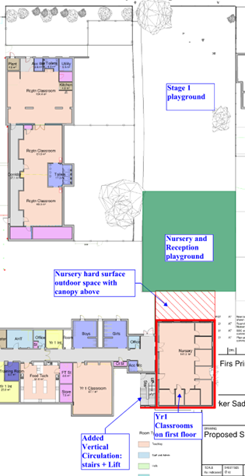

The design team appreciate that recreation area is a premium, however, this is not a viable option due to the limited budget and programme available.  It is also worth noting that your sketch suggests the repurposing of rooms which are rich in IT and have only recently been fitted out, therefore an expensive option. In addition, putting Y1 on the first floor disconnects them from the other Y1 classes, which is not preferred from a teaching perspective.

Alternatively, the rooms can extend on the back, leaving everything at ground floor:

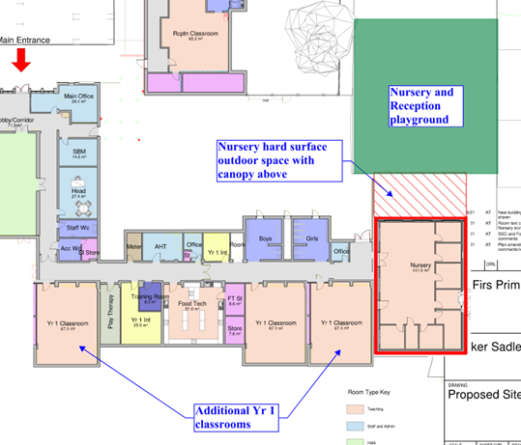

The design team have looked into this option but a single story extension with more than two exposed elevations was not considered a cost effective option.

4. The location of the new parking is very unfortunate, as it takes away a well grown edge of greening which includes mature bushes and trees. This vegetation is very important as it provides the following:

- acoustic: acting as a buffer, the foliage protects the children from the traffic noise

- it also absorbs pollution, trapping the particles and cleaning the air

- privacy: it protects the children from street view

- view: looking at greenery improves children and staff wellbeing

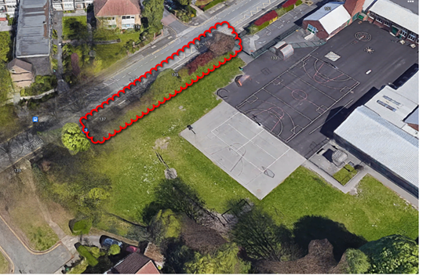

It would be a real shame to lose this for a parking lot. Clearly the green area needs to stay and the parking move down, as shown below:

 The design team are working with a restrictive site - they have tried to maintain a balance between providing much needed off road parking and not pushing the carpark too close to the tarmac courts, to ensure sufficient run off and space for wellbeing i.e. proximity of car fumes to the hard play court.  As recreation space is important, the brief was to provide adequate hard play that can be used in inclement weather (i.e. when the playing fields are unusable).  The design team have however reduced the extent of new hard surface in response to your comment.

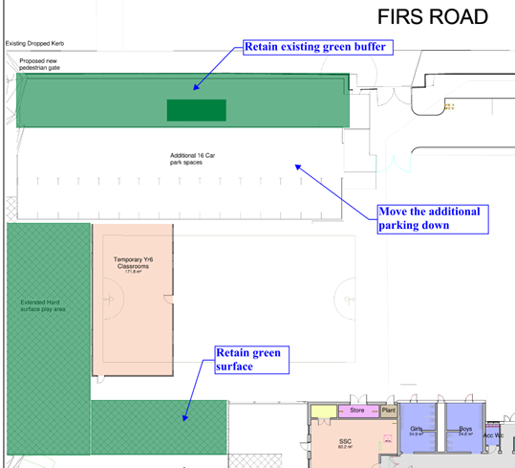

Or in a more compact shape, as in the current proposal half of the area is used for circulation rather than parking.

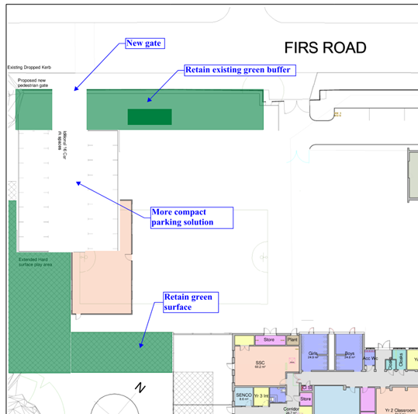

The area in front of the parking bays is the minimum dimensions necessary to facilitate perpendicular parking.  The parking layout indicated above affects the existing hard court and requires another vehicle access off Firs Road when there are already two existing, so isn’t viable. The proposal also brings the ‘public’ further into the site; albeit it fenced off, visitors will be closer to the Small Specialist Class play area which isn’t ideal.

Suggestion:

I am sure the staff have contributed to the design of the new school, however a big part of your stakeholders have been left out. The children! I would love to see their proposals and suggestions for improving their school. It is not too late to get them involved! The teachers should organise an internal consultation and ask them to design the new school. I've learned that they have much to offer and can really surprise us!

In addition, this would empower the children, give them an understanding of the need for extension and improvement, as well as make them more willingly accept the temporary disruptions to their routine, as they will know the purpose and end goal.

Children do indeed have a lot to offer but unfortunately, the design team are under a pre-determined programme to deliver the project in time to support the educational and school accommodation need. Numerous workshops have been held with the senior leadership team to develop the project and address the school’s pedagogy.  The contractor will engage the children in other ways, for example, site visits, talks on health and safety etc.  This has proven to be an enjoyable & educational experience for the children on other projects and has helped them understand what is happening to their school.

Questions:

1. With the works starting in September, all parents will be worried about the safety of children in a site construction. Have you already got a Health and Safety plan in place to describe how the construction site will be separated from the running school activities and what measures will the contractor have to implement in terms of minimising noise, dust and disruption during school hours?

This is being developed in detail with the Contractor, School and Principal Designer.  Please be assured that the health and safety of the children and school users is of paramount importance.  Conlon Construction are Considerate Constructors and have won many awards to reflect their commitment to considering the general public and securing safety on and immediately around their sites.

2. Has the contractor already prepared a logistic plan to locate machinery, separate entrance, separate services and storage of materials during construction, integrated with the programme and the temporary installments?

An initial site logistics plan has been prepared and approved by the school leadership team and Principal Designer for the initial Year 1 works being undertaken this summer. An overarching project wide logistics plan is under development at present and is being refined as the detail design work evolves and will inform a decant strategy to facilitate delivery of the full scope of the works. Dedicated contractors access , secure compound  for welfare facilities and material storage and vehicular movement have all been considered and will form part of the agreement of the logistics plan by the team.

3. Would you consider concentrating the most noisy and disrupting work during half terms, holidays and weekends? or limiting working hours after school?

This will be done wherever possible.

4. Have you appointed a fire engineer to review the fire strategy plan of the new arrangement?

The plans have been sent to Trafford council’s Fire Officer for his comments, and as part of the Building Regulation submission they will also be consulted.

5. Have you considered including in the plan photovoltaic panels or solar panels on the roof?

The use of photovoltaics (PV) and solar panels were considered early in the project. Given the additional requirements for safety systems and regular roof access for cleaning and maintenance etc, it was decided to progress other low carbon technologies in lieu of PV. The extension scheme will instead be provided with heating via an air source heat pump.

6. Have you considered specifying a responsible source for the materials, such as reclaimed bricks, recycled aluminium and glass?

Reclaimed bricks are not cost efficient for this project but we will be ensuring materials are sourced locally where reasonably practicable.

7. In the long term plan, is there any consideration to the future further expansion of the school, if any at all is possible, and how the current plan would be able to accommodate it?

There are no plans to expand the school further. Trafford do not have any Primary schools with more than 3 forms of entry.

8. Would the new extension use the mechanical services of the current school, or have a separate plant room? I can see one in the extension, not sure about the nursery?

The new extension will be provided with its own plant room to accommodate the main equipment serving the extension. The water and electrical connections will be derived from the schools existing plant room and infrastructure. Similarly, the new nursery will have its own integral services, which shall be connected back into the existing school.

9. What sort of heating system is the school using at the moment, and have you considered switching to electrical powered systems to align with the current de-carbonisation of the grid?

The existing school is provided with heating via both gas fired boilers and an air source heat pump. These systems will be retained. The new extension will be provided heating via electrically driven air source heat pumps.

10. Have you considered a life carbon assessment to minimise impact to the environment?

The design team will consider the overall energy requirements and future running costs, leading to long-term operational benefits to help the client achieve the best value solution whilst reducing the carbon impact.  They are working with environmental consultants to determine the optimum size for windows to maximise natural daylight, ventilation and control heat gain.  Improved daylighting reduces the artificial lighting usage and subsequently the energy use. Inextricably linked to replacement and frequency of maintenance is the carbon impact.  The specification of robust, low embodied carbon materials that can be sourced locally has an important part to play.  Because most of the embodied carbon is in the structure, they will look for ways to achieve maximum structural efficiency. If internal ceilings are not providing acoustic or fire protection, the entire element will be removed to help reduce the embodied carbon impact. The design team will take a fabric first approach. Design the buildings walls, roofs, floors, windows and doors with a high thermal performance exceeding that of the building regulations minimum requirements. This will reduce energy consumption & therefore running costs.

11. You mention a tender process already occurred and the D&B contractor is already appointed. With the project only developed to concept stage, having a price fixed with the contractor would not give much room for developing the design without incurring in extra costs, as any changes will be priced by the single contractor. How did you select the current contractor, what was the criteria based on (commercial/qualifications/availability/tender return quality)?

The contractor was procured using Trafford Councils STaR procurement team (Stockport, Trafford and Rochdale) who used the North West Construction Hub (NWCH) to seek expressions of interest. The interested Contractors were then assessed on price, quality of their submission and finally social value. The client, end user and project management team independently evaluated each bid from a quality point of view and feedback to procurement who collate these along with the costs and social value to select the preferred bidder.

12. Given the procurement strategy, how did you cover any risks of incurring in extra costs?

A client contingency is retained for any increase in costs once detailed design is undertaken whilst maintaining the build contingency. Value engineering is used as a last resort. The contractor will also carry a design risk allowance within their submitted costs at Contractor’s Proposal stage.

13. How is the project funded if I can ask?

The project is funded by Basic Need capital which is for the purpose of providing new school places.

Finally, a proposal.

I work for an engineering firm called ****, I am a qualified structural and facade engineer. My role as a consultant is to design, specify, review and supervise the works of building construction. I work very closely with Architects and Contractors to deliver projects regionally and internationally. I have 15+ years experience.

I would very much like to help the school and the community by offering these services for free, I would review and supervise the work of the team you have already in place. Within my company, I have access to experts in all fields of engineering, Fire, Materials, Environmental, MEP, Structure, Acoustic Lighting and more.

I can provide technical reviews of the design and specification, discuss options with the design team and the cost consultant.

I live very close to the school so it would be practical for me to check on the works, supervise the quality and offer technical solutions.

Let me know if you would like to discuss this opportunity.

If you think this is a possibility, I can apply for an internal Community Engagement Funding in ****, which would partially pay for my consultancy, and I would volunteer the rest, so the service would come at no cost for you.

Looking forward to hearing from you

Thank you for your comments and offer of assistance, however, we already have a full design team appointed by the partnering contractor. The project management team also have a team of technical advisers who will be involved in the design process to advise the client of any design deficiencies.